
St James’ Church of England Junior School
Upton Street, Gloucester GL1 4JU
Telephone: (01452) 520714
Email: admin@sjjs.dgat.org.uk
Website: www.st-james-junior.co.uk

Headteacher: Mrs E Gardiner
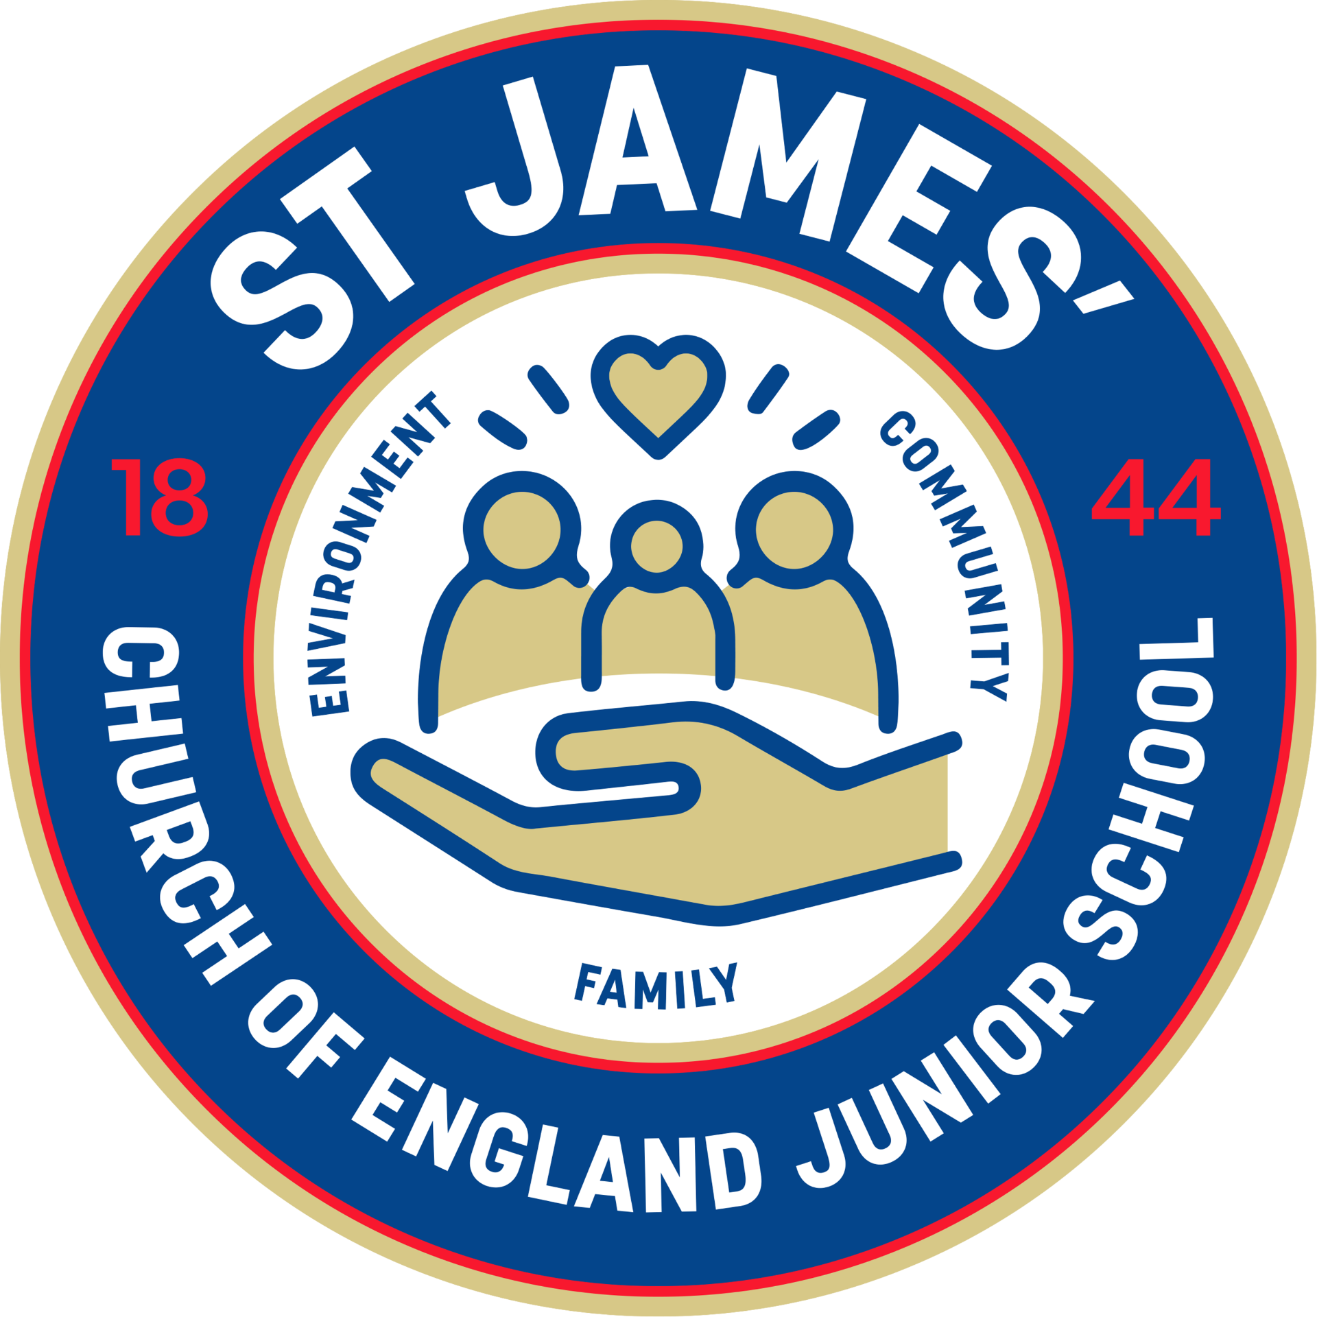

Developing the love of learning and life in a caring Christian community

School Prospectus
2026-27

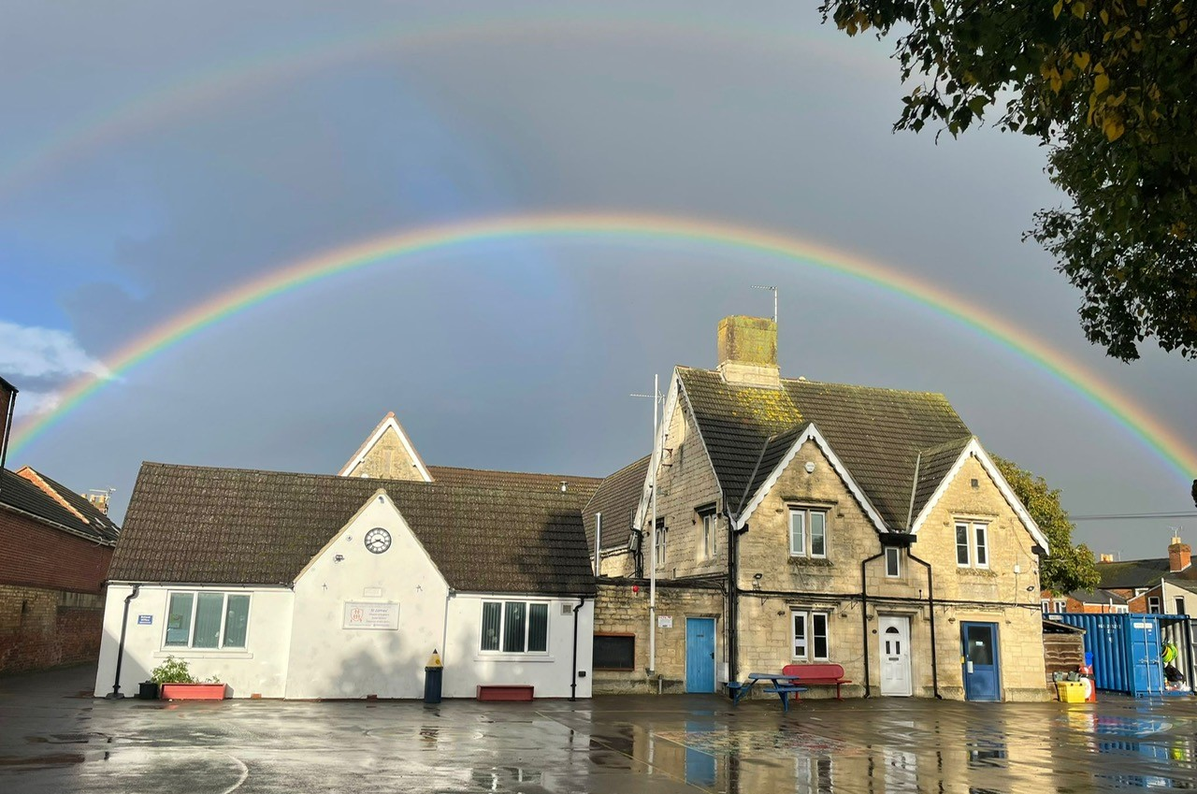

Welcome to St James’
Thank you for taking the time to read our prospectus. We hope it helps you gain an understanding of how our school is organised, and to appreciate the exciting opportunities on offer to children in our care
All schools have their own distinctive ‘feel’ which makes each one unique. We believe that the ‘special feel’ at St James’ is to do with our caring, friendly atmosphere. Our school continues to develop in many exciting ways, providing a rich diverse quality experience for our pupils.
On 1 May 2024, St James' Church of England Junior schools converted to academy status as part of the Diocese of Gloucester Academies Trust (DGAT). For information about DGAT please visit the DGAT website: Diocese of Gloucester Academies Trust
The school is made up of approximately 200 pupils aged from 7-11, in 8 classes, with a dedicated and hard-working team of staff and governors who ensure the children are placed at the forefront of everything we do.
We are passionate about working with children, families and our local communities. We aim to provide for all the children in our care a learning environment that enables them to develop the life skills they might need for our ever-changing world. We also work extremely closely and collaboratively with our closest Infant School; Hatherley.
Our school has a Christian Foundation which it seeks to promote by providing high quality educational opportunities for all members of our community. This is underpinned by Christian values, which by experience and example provide a basis for lifelong learning.
This prospectus goes some way to underlining our philosophy and gives an insight into how we operate. I would encourage you to make an appointment to have a look around the school in order that you can see us at work.
There is nothing more important to myself or my staff than the education of your child and this is underlined by the steps we take to ensure every child achieves their potential.
I look forward to meeting you and meeting your child when they start their educational journey with St James’ C of E Junior School.
Should you have any queries no matter how small, please do not hesitate to contact the school where we will be happy to help.

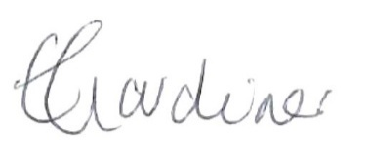
Emma Gardiner
Headteacher

Contents

Safeguarding
School Governors
Staff – Academic and Administrative
The school
School Hours
Admissions
Absence
School Uniform
PE kit
Breakfast and Lunchtime and School Meals
The Curriculum
Inclusion
Equal Opportunity
Special Educational Needs and Disabilities (SEND)
Pastoral Care
Policy Statements
Homework
Helping your child
Extra-Curricular Activities
INSET Training
School’s Charging Policy
Parental Consultation
Communication
Medicine
Medical and Dental Appointments
Illnesses and Accidents at School
Medical and Routine Checks
Behaviour and Discipline
School Procedures
House System
Prefects
Road Safety
Site information
School Calendars


Safeguarding
Nothing contained within this document overrides the current and ongoing commitment of the school to adhere to the Safeguarding of children, vulnerable adults or members of staff. Safeguarding of the children, vulnerable adults and members of staff is at the forefront of everything we do.
School Governors
The Hatherley St James' Local Governing Board – April 2025
The DGAT Trust Board delegates local oversight of its schools to local governing boards. Local governing boards are committees of the Trust Board. Hatherley Infant and St James' Church of England Junior schools have a single local governing board which is delegated responsibilities through a scheme of delegation (see below).
The LGB has the following members:
Type of governor | Name of Governor | Date Term Started | Date Term Ends
Foundation governor | Shirley Graham | 01/07/2024 | 30/06/2028
Substitute Foundation Ex-officio governor | Sukanmi Osunsanmi | 30/07/2024 | 29/07/2028
Parent governors | Bethany Butler  Vacancy | 01/04/2025 | 31/03/2029
Staff governors | Elliott Prince  Emma Faulkner | 01/05/2024  01/05/2024 | 30/04/2028  30/04/2028
Co-opted governors | Amanda Chong (Chair)  Jenni Vincent  Vacancy | 01/05/2024  01/05/2024 | 28/02/2027  30/04/2028
Headteacher ex-officio governor | Emma Gardiner
Trust appointed governor | N/A
Clerk to Governors | Roger Slater | clerk@his.dgat.org.uk

Governors Whose Term Ended or Who Stepped Down in the last 12 Months
Name of Governor | Type of Governor | Date Term Started | Date Term Ended
Syeda Begum | Parent Governor | 10/10/2024 | 07/03/2025
Fazila Patel | Parent Governor | 01/05/2024 | 31/08/2024
Shirley Graham | Parent Governor | 01/05/2024 | 30/06/2024
Juliet Jensen | Foundation Ex-officio governor | 01/05/2024 | 29/07/2024
The LGB will ensure that Hatherley Infant School and St James’ C of E Junior School will:
Serve the community of Hatherley Infant School by providing an education of the highest quality to enable children to develop and realise their skills and talents; to foster a sense of social responsibility and equal opportunity for all; and to ensure that all children develop a lifelong enjoyment of learning.
Recognising the foundation and preserving and developing the religious character in accordance with the principles of the Church of England and in partnership with the Church at Parish and Diocesan level, serve the community of St James’ C of E Junior school by providing an education of the highest quality within the context of Christian belief and practice. It encourages an understanding of the meaning and significance of faith and promotes Christian values through the experience it offers to all its pupils.

Academic Staff
Headteacher: | Mrs E Gardiner
Deputy Headteacher: | Mrs L Cossins
Senior Management/Class Teacher: | Mrs S Bingham-Morrison

Senior Management/SENDco  Designated Teacher of Looked After Children | Mrs E Faulkner

Teachers | Mrs E Acton  Mrs G Bate  Mrs S Bingham-Morrison  Miss L Bray  Miss R Dinwoodie | Miss M Evans  Mr J Hutchinson  Mr H Matthews  Mrs K McFarland  Miss A Tredgett
Cover Supervisor | Mrs H Major

Teaching Assistant | Mrs A Chew  Miss L Ellis | Mrs S McTaggart  Mr L Scutter  Miss G Williams  Mrs K Williams
 | Miss B Holford
Mrs R Odurny
Mrs F Pervaiz
Mid-day supervisor: | Mrs N Lulat

Administrative Staff
School Administrator Mrs R Hayward
School Business Manager/Finance Mrs S Wheeler
Caretaker Mr R Hood

The school
Vision: Developing the love of learning and life in a caring Christian community.
St James' Church of England Junior School has served the parish of St James’ since 1844; we are proud of this heritage.
The school community celebrates the fact that we are ‘more than a school, we are a family’.

Aims of the School
- We aim to work together in partnership with parents, governors, local community and Hatherley Infant School to provide an effective education for every pupil, regardless of ability, culture, gender, race, religious faith or economic or social circumstance.
- We aim to provide every pupil with the educational knowledge, skills, opportunities and resources to enable them to realise their full potential in an increasingly diverse society – both in the world of work and leisure.
- We aim to provide all staff with the opportunity to develop their professionalism in order that the quality of education is maintained at a high standard so that we deliver an ‘effective education’.
- We aim to affirm the Christian ethos and foundation of the school. We seek to preserve in all aspects of school life, the ethos, moral and spiritual values of the Christian faith, whilst respecting the other religious and cultural traditions of our community.

Our Shared Values

We feel that this positive approach to education is important, as it encourages the right attitudes, motivation and a real love for learning.

The school aims to establish and maintain good relationships with parents and the wider community. It is by working in partnership that the children's best interests are served.

The school strives to promote a supportive and caring environment where everyone feels valued and recognised, and there is a strong commitment to the welfare and wellbeing of the children.

The provision of challenging work at the appropriate level for each child helps to raise their self-esteem and gives them the opportunity to experience success and satisfaction.

All staff are committed to the development of the whole child. High standards of academic achievement, behaviour and spiritual development are actively encouraged.

We celebrate the cultural and religious diversity of our community.
School Hours
8:00 am | Gate opens for Breakfast Club
8:30 am | Parents can leave children on the playground
8:45 am | School starts
9:00 am | First session
10.50 – 11.05 am | Break time
12:00 pm | Collective worship Monday - Thursday, 9.00 am Friday
12:20 pm | Lunch time
1:10 pm | Registration
3:20 pm | End of school day
Breakfast Club is available from 8.00-8.30 am. Children are expected to be in school by 8.45 am punctual, but they should not arrive in school before 8.00 am unless they are going to Breakfast Club.

Punctuality
Children must be at School on time so that they are ready for the start of lessons.
Admissions
The school has a very close liaison with Hatherley Infant School and our transition process from Year 2 to Year 3 is excellent, however, we also admit children from other neighbouring schools. Some new children will already be familiar with St James' Church of England Junior School but all children who are registered to start in September will be invited along with their parents to an informal meeting during the term before the child is admitted. There will be opportunities to meet the Year 3 class teachers and to visit the child's future classroom. These visits by the children should ensure that the children feel happy with their new surroundings when they come to us in September.
During the year children from local Infant Schools are invited to take part in joint activities so that transition between the two schools is as seamless as possible.
Parents who are moving into the area or who are considering sending their child to the school, are invited to email the school to arrange a visit.
Any information that you consider to be of a personal or confidential nature please make an appointment to discuss with the Headteacher.
If any of the information relating to your child changes it is vitally important to inform the school office as soon as possible.

Absence
If your child is away from school for any reason, the office should be informed as soon as possible. Parents are asked to send a note explaining the absence, when their child returns, a verbal message from the child is insufficient.
In cases of longer illness, earlier notification would be appreciated. Often arrangements can be made for schoolwork to be sent home. Failure to notify the school of frequent or prolonged absences will result in a visit from the Family Support Worker and possibly a fine imposed by Gloucester County Council. This legal requirement ensures that both the school and parents are always aware of the child’s whereabouts. Please refer to the school’ Attendance Policy for more information about the school’s attendance procedures, including information concerning holiday requests.
Holidays during term time are not permitted.
School uniform
School uniform must be worn as this encourages the children to take pride in their appearance and makes them feel part of our school community. Every effort has been made to make the uniform as inexpensive as possible.
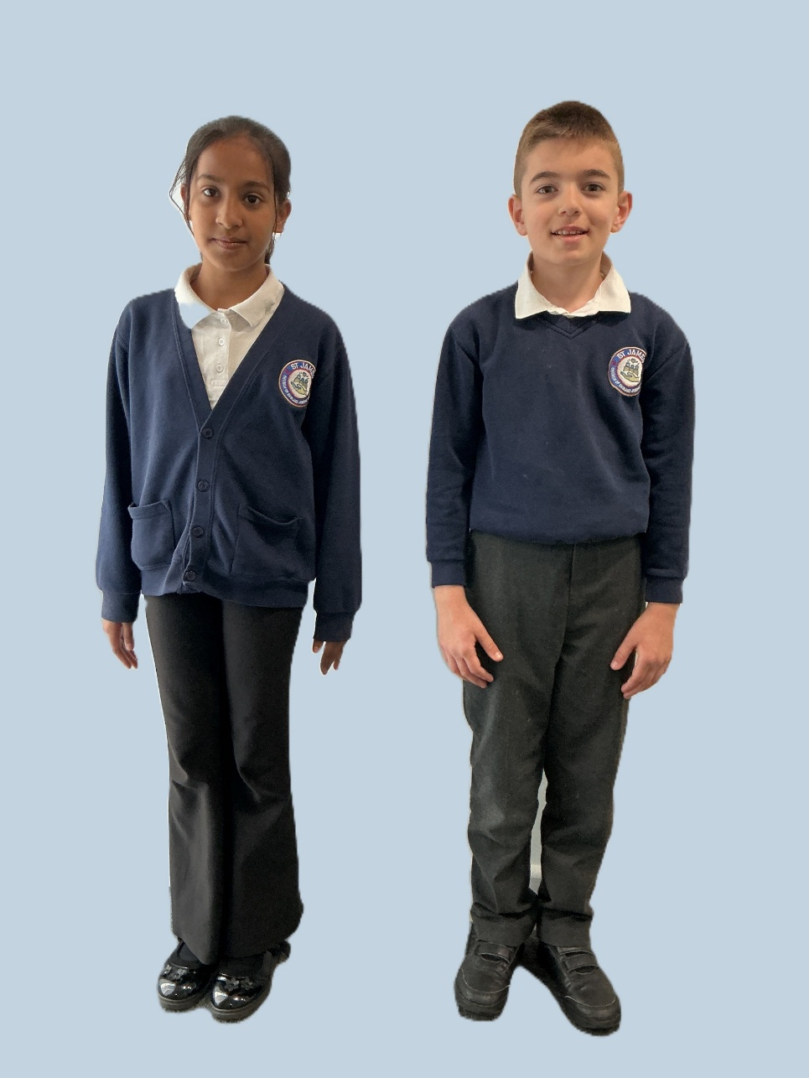
The school colours are Navy and Red, the school tie being
of a navy and red diagonal design.
The boys should wear:
- blue or white shirt – a polo shirt may be worn
- grey or black trousers (smart school shorts are permitted in the summer term)
- a navy jumper with school logo
- black footwear, no trainers
- a school tie from school
- a school bookbag purchased from school
- a suitable warm, waterproof, hooded coat (not hoodie).
The girls should wear:

- blue or white shirt – a polo shirt may be worn
- grey or blue skirt/trousers
- a navy jumper with school logo
- black footwear, no high heels or trainers
- a school tie from school
- a school book bag purchased from school
- a dark blue headscarf can be worn by Muslim girls
- a suitable warm, waterproof, hooded coat (not hoodie).

NO HOODIES SHOULD BE WORN TO SCHOOL EXCEPT FOR NON-UNIFORM DAYS.
School shoes – Trainers should not be worn as school shoes.
School ties, book bags and T-shirts (house colours) can be purchased from the school office only.
PE Kit
All PE Activities Swimming
A house-coloured school logo T-shirt An all-in-one swimsuit/trunks
(available from school) A towel
PE shorts blue or black A swimming cap
PE shoes/trainers
School jumper or navy-blue tracksuit in winter. No hoodies.
Needed for Football
Football shirt (or T-shirt) Football shorts (or PE shorts) Football boots
All of the above articles, excluding house T-shirts, ties and bags, will be found in the Monkhouse Uniform Shop (Northgate Street) and should be easily available from most large stores such as ASDA, Tesco, Primark. If there are any difficulties, please contact the school office.
Please ensure that all items are labelled clearly with the name of your child.

Breakfast and Lunchtime
Breakfast Club
Opening Times: 8:00 - 8:30 am
At St James’ we are lucky enough to serve bagels or cereal with a choice of juice or milk to all children free of charge.
Children can attend Breakfast Club and socialise with their friends. Alternatively, bagels are available on the playground as a ‘grab and go’ option.
St James’ C of E Junior School is proud to be in partnership with the National School Breakfast Programme, providing healthy breakfasts to our pupils so that they are settled and ready to learn. The National School Breakfast Programme provides St James with nutritious breakfast food to ensure children start their school day in the best possible way. Breakfast gives children the energy needed for the busy school morning, enabling them to focus on their lessons https://www.family-action.org.uk/
School Meals
The school meals are cooked off-site by Caterlink and are brought to the school each day. Menus are available on our website. The children eat their school meals in the hall. Meals cost £2.95 per day or £14.75 per week via Parentpay. Money for school meals should be paid for using the ‘Parentpay’ system located at www.parentpay.com A username and password will be supplied by the school for parent access. Parents/carers are reminded that meals should be paid for in advance and there should always be a credit on the account. Should there be any problems in paying or your account is in debt then the Headteacher should be consulted.
Children requiring a special menu can be accommodated, providing Caterlink are notified in advance, alternatively children may bring sandwiches.
During periods of temporary hardship, parents are invited to apply for free school meals, full details are available on our website.

Lunchboxes and Snacks
Is your child’s snack healthy?
It could be:
Fresh fruit, dried fruit, vegetables, crackers, bread sticks, low fat cereal bars, a drink (we recommend water, but it could be sugar-free squash or fruit juice). Children should bring their own drinks bottle into school (not glass). Please don't use one-use plastic.
It shouldn’t be:
Doughnuts or cakes, crisps, chips, chocolate bars, fast food/pot noodles, fizzy, high-sugar drinks or hot drinks.
Is your child’s lunchbox healthy?
It could be:
- One portion of fruit or vegetables
- A source of protein (eg meat, fish, lentils, beans)
- Some starchy food (eg wholemeal/seeded bread sandwiches/rolls, pasta, crackers, wraps)
- Dairy food (eg cheese or yoghurt) a drink (we recommend water, but it could be sugar-free squash or fruit juice). No hot drinks.
It shouldn’t be:
Doughnuts or cakes, crisps, chips, chocolate bars, fast food/pot noodles, fizzy or high sugar drinks.
If you send fresh fruit (kiwi fruit or oranges etc.) please, wherever possible, peel and prepare it for your child. We are a NO NUT school due to allergies. Please do not send any nuts into school in your child’s lunchbox.
Need help? https://www.nhs.uk/change4life-beta/healthier-lunchboxes

The Curriculum
The central aims of our curriculum are to work in collaboration with families and the local community to provide opportunities for all pupils to learn and to achieve; to promote pupils’ spiritual, moral, social and cultural development and prepare all pupils for the opportunities, responsibilities and experiences of life.
The curriculum of the school is organised so that children are stimulated, encouraged and challenged to develop their individual potential and personality to the full. The school’s curriculum promotes and sustains a thirst for knowledge and understanding, and a love of learning.
The curriculum is constantly changing to develop the skills needed for children to become successful learners, help prepare them for life in modern Britain and empower them to achieve success in the future.
Our curriculum is planned in themes, with topics chosen to capture the interests and imaginations of our children.
Skills-based learning is developed by linking subjects such as history, geography, art, design technology and music to the topic being studied. This allows children to make purposeful links in their learning. We also use every opportunity to make further links through reading, writing, maths, science and computing where relevant. PE, RE and PSHE are often taught as discreet subjects to allow coverage of the main objectives and age-appropriate skill development.
In addition to our exciting and stimulating themes, we also provide further opportunities to enhance children’s learning wherever possible. This includes: a visiting pantomime, educational trips, Forest School experience, visits to places of worship and visiting teachers.
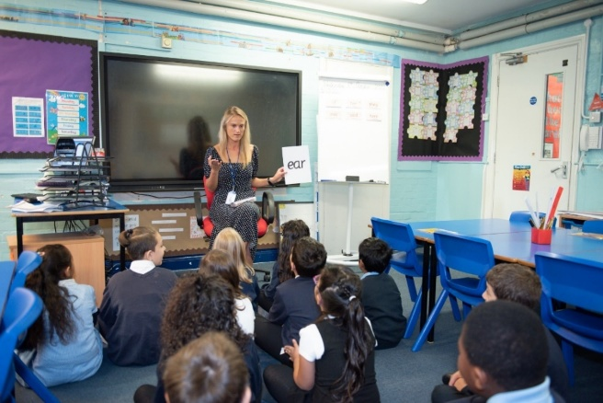
Inclusion
St James’ Church of England School is an inclusive school, employing equal opportunities for all our pupils whatever their gender, ethnicity, attainment or background. We value diversity and aim to meet specific needs of every child through supporting them or setting them appropriate challenge, so every child reaches their full potential. We want every child, parent or carer to feel secure, valued and part of our school community.
Equal Opportunity

In line with the County's Equal Opportunity/Equality Policies, this School tries to ensure that every child has equality of access to all aspects of the curriculum and school life. We abide by the Equalities Act 2010.

Special Educational Needs and Disabilities (SEND)
At St James we aim to enable all children to achieve their full potential. We have a secure system of early identification, planning and monitoring for when a child requires additional support. The school will work closely with his/her parents to enable the child to receive the necessary educational support using My Plans and interventions to support learning.
We are fortunate here that we have an experienced SENDCo who is not class based.
Details of our local offer can be found on our website.
- The whole aim of SEND is to HELP CHILDREN by meeting their needs as much as is possible.
- The support and involvement of parents is crucial.
An effective PARTNERSHIP between home and school is essential.
Pastoral Care

The school has a comprehensive Pastoral system designed to help pupils feel safe, valued and achieve.

Policy Statements
Policies can be inspected at the school on request or viewed on our website.

Homework
Children are encouraged to read, practise spellings and learn their tables daily. Occasionally children may be asked to do some fact-finding work on a particular project. Parental co-operation in completing work is also sought after a child's prolonged absence or when insufficient work is achieved during the school day.
Helping your child
Parents can help their children in a variety of ways:
- Listening to your child read at least 3 times a week and talking about the content of the book
- Helping your child to learn spellings and tables
- Naming all items of personal property
- Encouraging your child to take responsibility for the organisation of the equipment
- Teachers are always happy to discuss how you can support your child.

Extra-Curricular Activities
We encourage the children to join some of the many after school activities organised through the goodwill of staff.
Some of these activities take place during lunch time, but many occur after school hours. Children are asked to give their parents at least 24 hours’ notice when they know they will be staying late to attend an activity. Occasionally, visits are organised for individual classes or groups of children and parents are always notified of these visits well in advance.
Out-of-school activities are voluntary, both for the child and for the teacher. The school values greatly the dedication of the staff without whom much of this varied curriculum would be lost.
INSET Training
Teaching and non-teaching staff regularly undertake Inset training to ensure that the education delivered to all the pupils of St James’ Church of England Junior School is of the highest standard. These dates are published in advance every academic year/term.

School’s Charging Policy
Following advice from the Local Education Authority, the School's Governing Body has implemented the recommended Charging Policy, with minor alterations to suit our school. This amended Charging Policy, which is applicable to our school, is held in school for parental inspection; it may affect any activity that involves funding.
Church Services at St James’ Church
Parents are invited to attend the following services that are run by the school: Easter, Awards Service, Harvest and Christmas. All other services (unless otherwise notified) are run by the Church.

Parental Consultation
The Class Teacher, in consultation with the Headteacher, accepts full responsibility for the educational and pastoral welfare of his or her children. Parents with general worries and/or queries about their children are encouraged to talk initially with the class Teacher.
The school provides to parents, an annual written progress report on their child. Teacher and parent can then discuss the child's areas of achievement, improvement and development. Parents’ evenings are arranged twice yearly.
The Headteacher welcomes visits by parents on any matter which concerns the welfare and progress of the child. However, it is necessary to make an appointment in advance, by letter, email or by telephone. All visitors need to call first at the school office to sign in and collect a visitor’s badge.
Sensitive children can spend days worrying about things which to adults seem trivial. To alleviate these problems in the early stages, the teacher needs to be kept aware, so please do contact the teacher to discuss the matter.

Specific information for Secondary School selection is given to all parents of Year 6 children in the Autumn term. The Headteacher and Class Teacher will be available at a mutually convenient time to discuss this information in more detail, if the parent so wishes.

Communication
We communicate with parents in the following ways:
- Texts/Emails/In-app messages via Arbor’s Parent Portal
- Letters via the pupil/email/website
- Newsletters via email/website
- Telephone
- Website information

Parents and School
It is one of our aims to cultivate good home-school relationships. Should you wish to offer an hour or two of your time, please contact the Headteacher. All parent helpers may be subject to an enhanced DBS check and a risk assessment check.

Medicine
In extreme cases where medicine must be taken in school, a form must be filled in at the office. If the request is authorised, the medicine must be clearly labelled with the child's name and the dosage required. In some cases, it may be necessary for parents/carers to attend the school to administer the medicine.
Medical and Dental Appointments
Only urgent medical, dental and orthodontist appointments should be made during the school day. Please try and make routine appointments after school and during the school holidays.
When such an absence is known in advance, please notify your child's class teacher. If your child will be out of school in the morning but back for lunch, please make sure you let us know if they require a school lunch to be ordered. If the appointment is during school time, parents are required to come into the school office before collecting their child to sign the child out of school.

Illness and Accidents at School
Parents will be contacted at home or at their place of work if there is an illness or accident at school involving their child. The appropriate action will be taken on such occasions. In cases requiring immediate medical attention, the Headteacher or another approved member of staff will take the child to hospital for treatment and then contact the Parent. It is, therefore, essential to have a day-time "contact" telephone number and mobile.

Medical and Routine Checks
The School Medical Service visits the school to undertake a range of activities; for example, the School Nurse supports the school in developing a healthy lifestyle. Parents will be notified if any medical meeting is considered necessary and are invited to be present when this meeting takes place.

Behaviour and Discipline
All children are expected to attain and maintain high standards in appearance and behaviour, whilst in and out of school. In this, we are helped and supported by the children's home environment. The school has a clear Behaviour Policy, which outlines expected behaviour. The policy can be inspected on request or can be viewed on our website.

Every child is expected to follow the school rules:
We respect ourselves and others
We care for each other
We follow instructions so that we can achieve
We take care of our environment
We help each other to learn

School procedures
They are designed for every child's safety and the well-being of all in school.
- All clothing should be clearly marked with the name of the child.
- For the safety of all: No jewellery is to be worn in school. If a child must wear pierced earrings, then only two may be worn and they must be the plain stud-type earrings.
- All earrings and other jewellery must be removed, by the pupil, for all swimming and PE lessons. Hooped or dangly earrings should not be worn in school, only studs.
- Money: All money brought to school should be placed in an envelope clearly marked with the child's name, class, amount and purpose of the money. This money should be handed to the class teacher as soon as possible.
- Do not bring toys or other valuables into school.
- Mobile phones must be turned off and left in the red box in the office.
- Staff cannot be held responsible for money or other valuables.
- The children are encouraged to bring in fruit into school but under no circumstances should they bring sweets.
- No child is allowed to leave the premises at any time during school hours unless permission has previously been given by a teacher and the Headteacher and they must be picked up by a parent/carer or someone else given permission by a parent/carer.
- Children who have lunch in school are not allowed to leave the premises at any time during the lunch break.
- Children should not play in the area where staff cars are parked. Two solid yellow lines show the limit of the playground. Solid and dotted yellow lines indicate restricted areas and areas of play.
- Bullying, fighting (including ‘play’ fighting) and the use of abusive language are not allowed and will not be tolerated under any circumstances. Proven cases will be dealt with severely. Please note that as part of our duty of care, staff are trained in physical intervention techniques necessary to ensure effective education for all pupils.
House System
There are four houses:
RUBY SAPPHIRE AMBER EMERALD
Children are allocated a house when they enter school. Tokens are given out for good work, etc. There is a termly House award.
Prefects
We now have a tradition of selecting the children in Year 6 to become Prefects. Not all children become Prefects, only those who have shown amongst other traits:
- Exceptional behaviour
- Compassion to others
- The ability to achieve above and beyond what is expected of them.
As part of the Prefect structure, we also have
- A Head boy
- A Head girl
- A Deputy Head boy
- A Deputy Head girl
These are children chosen by the members of staff at St James’ who go beyond the requirements above and have been able to maintain these during their time at school.

Road Safety
The school is situated near several busy streets. Children are reminded about the need for Road Safety. We expect children to behave sensibly, at all times, on and near the roads, so that their safety is always ensured. However, the safety of pupils on their journey to and from school, remains the responsibility of parents. This includes the immediate area outside of the school ground.
In the interests of safety, no parking or waiting in the car is allowed on the zigzag and double yellow lines outside both School entrances/exits.

Smoking
Smoking/vaping is not allowed anywhere on the school grounds.
Dogs
Dogs are not allowed on the school site or around the gate areas.
Bikes, scooters etc
To protect the children, no bikes, scooters or the like are to be used across the school grounds. They are to be pushed or carried at all times.
If a pupil wishes to ride to school, they will need permission from school to bring their bike onto the school grounds, this is subject to the following requirements;
- Bikes must be road worthy
- Must have cycle helmet and reflectors must be worn
- Bikes and scooters must have lock
All bikes and scooters are left at the owner’s risk. St James’ Junior School is not responsible for any theft or damage to bikes left on school site.
On-site parking and turning
Onsite parking is restricted to members of staff only as there is limited space available and allowing unauthorised vehicles onto the school grounds may be a danger to the children. Parents and members of the public are not permitted to use a motor vehicle to drive across, turn or otherwise access the school grounds except in exceptional circumstances authorised by the Headteacher. Parents should not park in front of the school gates at any time during the day.
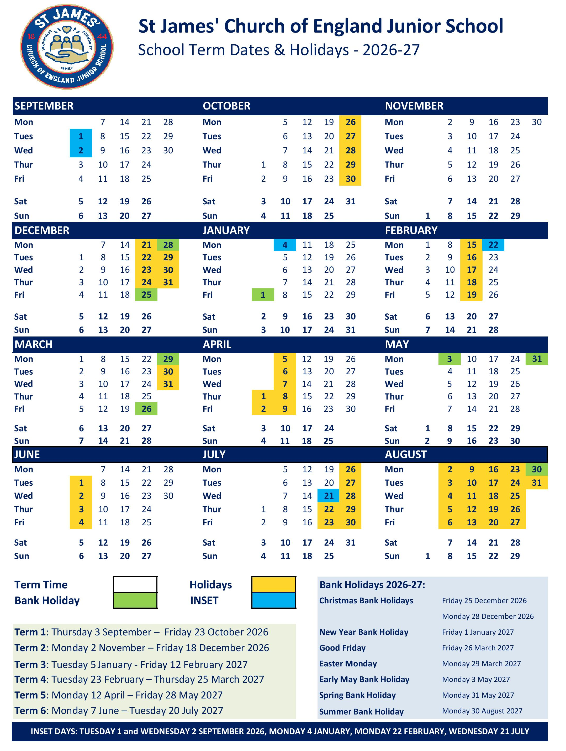

The information in this prospectus is correct, as far as is known, at the time of printing and maybe subject to change without prior notice.

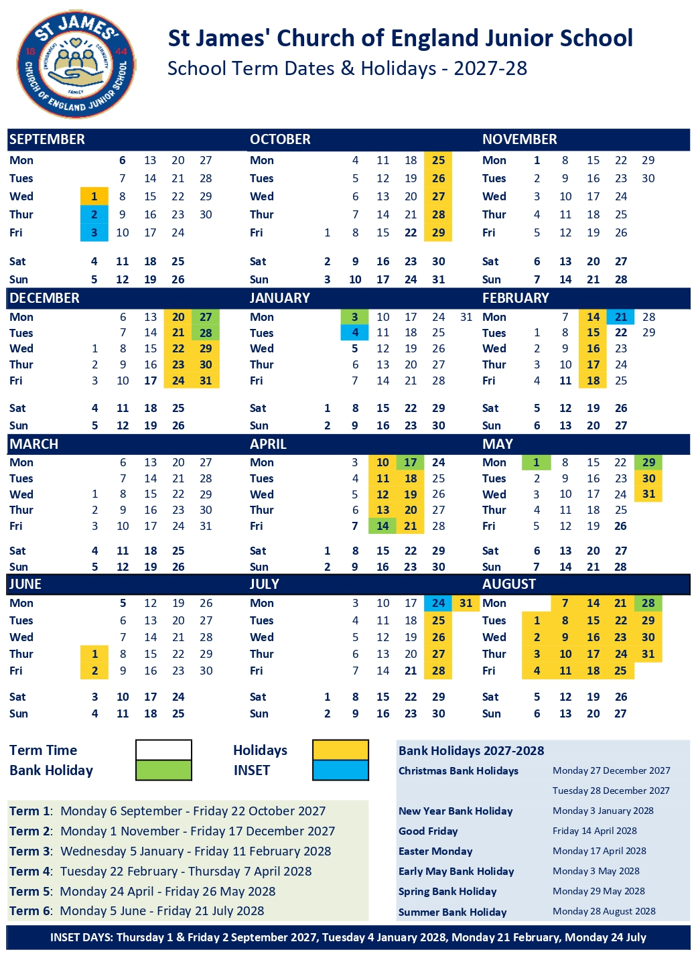
The information in this prospectus is correct, as far as is known, at the time of printing and maybe subject to change without prior notice.

